CSCI 236 Python Programming Fall 2018

Chapter 1 Activity 1

1. Start up an interactive Python session and try typing in each of the following commands. Write down the results you see.

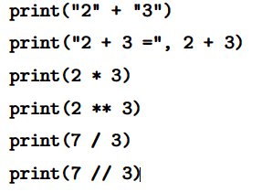

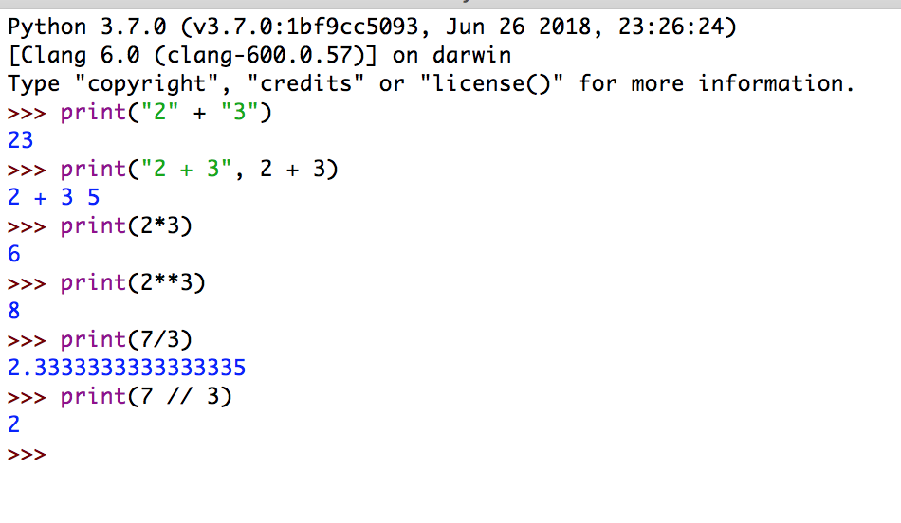

1. Modify the chaos program so that the number of values to print is determined by the user. Take and attach a screenshot of your python shell showing the output.

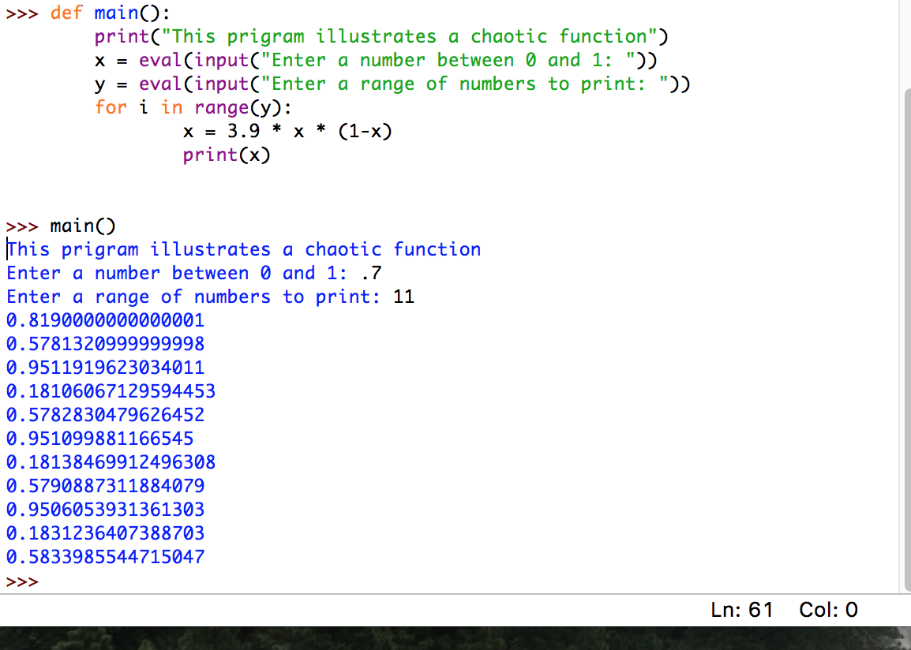

1. As you will learn in a later chapter, many of the numbers stored in a computer are not exact values, but rather close approximations. For example, the value 0.1 might be stored as 0.10000000000000000555. Usually, such small differences are not a problem; however, given what you have learned about chaotic behavior in Chapter 1, you should realize the need for caution in certain situations. Can you think of examples where this might be a problem? Explain.

In large scale calculations this can result in additional figures or losses in actual data. Companies that handle large volumes of payments for example could shave off millions of dollars from leftover decimal places.